**The model**

The process I use to simulate the data and then estimate to effects is based on a relatively straightforward logistic regression model with two random effects. To simplify things a bit, I intentionally make the assumption that there are no general time trends that affect that outcomes (though it would not be difficult to add in). In the logistic model, the log-odds (or logit) of a binary outcome is a linear function of predictors and random effects:

\[ \text{logit}(P(y_{ict}=1) = \beta_0 + \beta_1 I_{ct} + b_{ct} + b_i,\]  
where \(\text{logit}(P(y_{ict}=1))\) is the log-odds for individual \(i\) in cluster (or site) \(c\) during time period \(t\), and \(I_{ct}\) is a treatment indicator for cluster \(c\) during period \(t\).

There are two random effects in this model. The first is a cluster-specific period random effect, \(b_{ct}\) . For each cluster, there will actually be a vector of cluster effects \(\mathbf{b_c} = (b_{c0}, b_{c1},…,b_{c,T-1})\), where \(\mathbf{b_c}\sim MVN(\mathbf{0}, \sigma_{b_c}^2\mathbf{R})\), and \(\mathbf{R}\) is

\[  
\mathbf{R} =  
\left(  
\begin{matrix}  
1 & \rho & \rho^2 & \cdots & \rho^{T-1} \\  
\rho & 1 & \rho & \cdots & \rho^{T-2} \\  
\rho^2 & \rho & 1 & \cdots & \rho^{T-3} \\  
\vdots & \vdots & \vdots & \vdots & \vdots \\  
\rho^{T-1} & \rho^{T-2} & \rho^{T-3} & \cdots & 1  
\end{matrix}  
\right )  
\]

The second random effect is the individual or patient-level random intercept \(b_i\), where \(b_i \sim N(0,\sigma_{b_i}^2)\). We could assume a more structured relationship for individual patients over time (such as a decaying correlation), but in this application, patients will not have sufficient measurements to properly estimate this.

In the model \(\beta_0\) has the interpretation of the log-odds for the outcome when the the cluster is still in the control state and the cluster-period and individual effects are both 0. \(\beta_1\) is the average treatment effect conditional on the random effects, and is reported as a log odds ratio.

**Simulating the study data**

I am going to generate a single data set based on this model. The only real difference here is that I am generating an outcome that is a function of cluster-period effects, individual effects, and treatment status.

**Site level data**

There will be 24 sites followed for 12 periods (\(t=0\) through \(t=11\)), and the stepped-wedge design includes 6 waves of 4 sites in each wave. The first wave will start at \(t=4\), and a new wave will be added each period, so that the last wave starts at \(t=9\).

library(simstudy)

dsite <- genData(24, id = "site")

dper <- addPeriods(dsite, nPeriods = 12, idvars = "site",

perName = "period")

dsw <- trtStepWedge(dper, "site", nWaves = 6, lenWaves = 1,

startPer = 4, perName = "period",

grpName = "Ict")

**Correlated site-level effects**

The average site-level effect is 0, the standard deviation of site averages is \(\sigma_{ct} = 0.3\), and the correlation coefficient that will determine between-period within site correlation is \(\rho = 0.5\). The correlation structure is “AR-1”, which means the between-period correlation decays over time (see definition of \(\mathbf{R}\) above.)

siteDef <- defData(varname = "[eff.mu](http://eff.mu)", formula = 0,

dist = "nonrandom", id = "site")

siteDef <- defData(siteDef, varname = "eff.s2", formula = 0.3^2,

dist = "nonrandom")

dsw <- addColumns(siteDef, dsw)

dsw <- addCorGen(dsw, nvars = 12, idvar = "site", rho = 0.5,

corstr = "ar1", dist = "normal",

param1 = "[eff.mu](http://eff.mu)", param2 = "eff.s2",

cnames = "[eff.st](http://eff.st)")

dsw <- dsw[, .(site, period, startTrt, Ict, [eff.st](http://eff.st))]

**Patient level data**

We are generating 20 patients per period for each site, so there will be a total of 5760 individuals (\(20\times24\times12\)). The individual level effect standard deviation \(\sigma_{b_i} = 0.3\). Each of the patients will be followed until they die, which is a function of their health status over time, defined by the Markov process and its transition matrix defined below.

dpat <- genCluster(dper, cLevelVar = "timeID",

numIndsVar = 20, level1ID = "id")

patDef <- defDataAdd(varname = "S0", formula = "0.4;0.4;0.2",

dist = "categorical")

patDef <- defDataAdd(patDef, varname = "eff.p",

formula = 0, variance = 0.3^2)

dpat <- addColumns(patDef, dpat)

P <-t(matrix(c( 0.7, 0.2, 0.1, 0.0,

0.1, 0.3, 0.5, 0.1,

0.0, 0.1, 0.6, 0.3,

0.0, 0.0, 0.0, 1.0),

nrow = 4))

dpat <- addMarkov(dpat, transMat = P,

chainLen = 12, id = "id",

pername = "seq", start0lab = "S0",

trimvalue = 4)

dpat[, period := period + seq - 1]

dpat <- dpat[period < 12]

**Individual outcomes**

In this last step, the binary outcome \(y_{ict}\) is generated based on treatment status and random effects. In this case, the treatment lowers the probability of \(Y=1\).

dx <- merge(dpat, dsw, by = c("site","period"))

setkey(dx, id, period)

outDef <- defDataAdd(varname = "y",

formula = "-0.5 - 0.8*Ict + [eff.st](http://eff.st) + eff.p",

dist = "binary", link = "logit")

dx <- addColumns(outDef, dx)

dx <- dx[, .(site, period, id, Ict, y)]

Here are the site-level averages over time. The light blue indicates periods in which a site is still in the control condition, and the dark blue shows the transition to the intervention condition. The lines, which are grouped by wave starting period, show the proportion of \(Y=1\) for each period. You should be able to see the slight drop following entry into treatment.

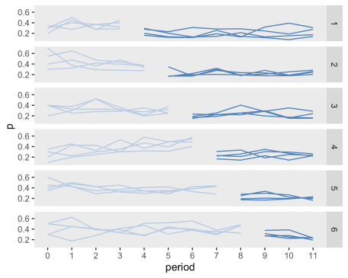

**Estimating the treatment effect and variance components**

Because none of the maximum likelihood methods implemented in R or SAS could estimate this specific variance structure using a mixed effects logistic regression model, I am fitting a Bayesian model using [RStan and Stan](http://mc-stan.org/), which requires a set of model definitions.

This model specification is actually quite similar to the model I estimated [earlier](https://www.rdatagen.net/post/bayes-model-to-estimate-stepped-wedge-trial-with-non-trivial-icc-structure/), except of course the outcome distribution is logistic rather than continuous. Another major change is the use of a [“non-centered” parameterization](https://mc-stan.org/docs/2_21/stan-users-guide/reparameterization-section.html), which actually reduced estimation times from hours to minutes (more precisely, about 12 hours to about 30 minutes). This reparameterization requires a Cholesky decomposition of the variance-covariance matrix \(\Sigma\). One additional limitation is that proper convergence of the MCMC chains seems to require a limited prior on \(\rho\), so that \(\rho \sim U(0,1)\) rather than \(\rho \sim U(-1,1)\).

This particular code needs to be saved externally, and I have created a file named binary sw - ar ind effect - non-central.stan. This file is subsequently referenced in the call to RStan.

data {

int I; // number of unique individuals

int N; // number of records

int K; // number of predictors

int J; // number of sites

int T; // number of periods

int ii[N]; // id for individual

int jj[N]; // group for individual

int tt[N]; // period of indidvidual

matrix[N, K] x; // matrix of predictors

int y[N]; // vector of binary outcomes

}

parameters {

vector[K] beta; // model fixed effects

real sigma_S; // site variance (sd)

real rho; // correlation

real sigma_I; // individual level varianc (sd)

// non-centered paramerization

vector[T] z_ran_S[J]; // site level random effects (by period)

vector[I] z_ran_I; // individual level random effects

}

transformed parameters {

cov_matrix[T] Sigma;

matrix[T, T] L; // for non-central parameterization

vector[I] ran_I; // individual level random effects

vector[T] ran_S[J]; // site level random effects (by period)

vector[N] yloghat;

// Random effects with exchangeable correlation

real sigma_S2 = sigma_S^2;

for (j in 1:T)

for (k in 1:T)

Sigma[j,k] = sigma_S2 * pow(rho,abs(j-k));

// for non-centered parameterization

L = cholesky_decompose(Sigma);

for(j in 1:J)

ran_S[j] = L * z_ran_S[j];

ran_I = sigma_I * z_ran_I;

// defining mean on log-odds scale

for (i in 1:N)

yloghat[i] = x[i]*beta + ran_S[jj[i], tt[i]] + ran_I[ii[i]];

}

model {

sigma_I ~ exponential(0.25);

sigma_S ~ exponential(0.25);

rho ~ uniform(0, 1);

for(j in 1:J) {

z_ran_S[j] ~ std_normal();

}

z_ran_I ~ std_normal();

y ~ bernoulli_logit(yloghat);

}

**Set up the data and call stan from R**

Just for completeness, I am providing the code that shows the interface between R and Stan using RStan. The data needs to be sent to Stan as a list of data elements, which here is called testdat. For the estimation of the posterior probabilities, I am specifying 4 chains of 4000 iterations each, which includes 1000 warm-up iterations. I specified “adapt_delta = 0.90” to reduce the step-size a bit (default is 0.80); this slows things down a bit, but improves stability.

As I mentioned earlier, with this data set (and rather large number of effects to estimate), the running time is between 30 and 45 minutes. One of the downsides of this particular Bayesian approach is that it wouldn’t really be practical to do any kind of sample size estimate.

x <- as.matrix(dx[ ,.(1, Ict)])

I <- dx[, length(unique(id))]

N <- nrow(x)

K <- ncol(x)

J <- dx[, length(unique(site))]

T <- dx[, length(unique(period))]

ii <- dx[, id]

jj <- dx[, site]

tt <- dx[, period] + 1

y <- dx[, y]

testdat <- list(I=I, N=N, K=K, J=J, T=T, ii=ii, jj=jj, tt=tt, x=x, y=y)

library(rstan)

options(mc.cores = parallel::detectCores())

rt <- stanc("binary sw - ar ind effect - non-central.stan")

sm <- stan_model(stanc_ret = rt, verbose=FALSE)

fit.ar1 <- sampling(sm, data=testdat,

iter = 4000, warmup = 1000,

control=list(adapt_delta=0.90,

max_treedepth = 15),

chains = 4)

**Diagnostics**

After running the MCMC process to generate the probability distributions, the trace plots show that the mixing is quite adequate for the chains.

plot(fit.ar1, plotfun = "trace", pars = pars,

inc_warmup = FALSE, ncol = 1)

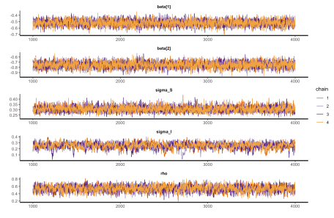

**Extracting results**

If we take a look at the posterior probability distributions, we can see that they contain the original values used to generate the data – so at least in this case, the model seems to model the original data generation process quite well.

pars <- c("beta", "sigma_S","sigma_I","rho")

summary(fit.ar1, pars = pars, probs = c(0.025, 0.975))$summary

## mean se_mean sd 2.5% 97.5% n_eff Rhat

## beta[1] -0.519 0.000687 0.0459 -0.609 -0.428 4470 1

## beta[2] -0.751 0.000844 0.0573 -0.864 -0.638 4618 1

## sigma_S 0.307 0.000394 0.0256 0.260 0.362 4223 1

## sigma_I 0.254 0.001548 0.0476 0.148 0.337 945 1

## rho 0.544 0.001594 0.0812 0.376 0.698 2599 1

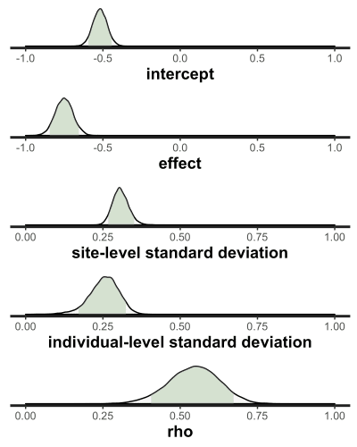

One thing that is not working so well is my attempt to compare different models. For example, I might want to fit another model that does not assume between-period correlations decay and compare it to the current model. Previously, I used the bridgesampling package for the comparisons, but it does not seem to be able to accommodate these models. I will continue to explore the options more model comparison and will report back if I find something promising.

This study is supported by the National Institutes of Health National Institute on Aging R61AG061904. The views expressed are those of the author and do not necessarily represent the official position of the funding organizations.